How to Draw a Rural Lane
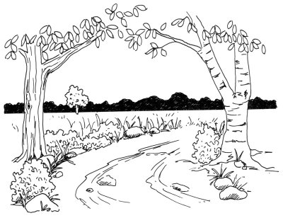

With a forest silhouette in the background and a canopy of trees in the foreground, this rural lane is a peaceful nature scene. This landscape is a wonderful drawing challenge for nature lovers.

In this section, we'll show you how to draw this rural lane landscape. You can draw it freehand while looking at your computer monitor, or you can print out this page to get a closer look at each step.

Here, we'll show you an illustration of each step and then give you a description of how to draw it. Follow the red lines in each illustration to learn exactly what to draw in that step. The lines drawn in previous steps are shown in gray.

To start drawing a rural lane landscape, draw a horizon line just above the center of the page.

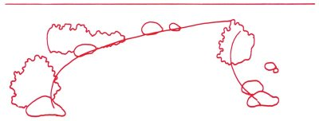
Step 1: Lightly draw a horizon line just above the center of the page. Rough in two long, curving lines that come together somewhat for the outline of the road. Draw a few large ovals for rocks, placing them randomly along the sides of the road. Make three bushes with squiggly lines to define the roadway and distinguish it from the surrounding fields.

To draw a rural lane landscape, sketch a tree and branches on the left, with a tall main trunk.
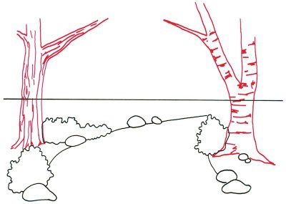

Step 2: Sketch a tree and branches on the left, with a tall main trunk. Show the bark on the side of the trunk with long up-and-down lines. Use short horizontal lines for the tree on the right, a birch, which has a smaller main trunk. When filling in lines on the birch, notice that the lines are roughly horizontal, not vertical like the other tree.

To draw a rural lane scene, sketch several irregular oblong shapes on the road to look like rocks and stones.

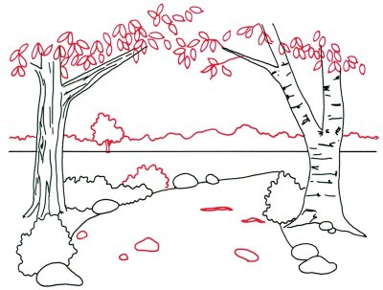
Step 3: Draw a squiggly line across the page, just above the horizon line, to indicate the tops of distant trees. Add smaller branches to the trees with a few crooked lines. Arrange dozens of leaves in random clumps by sketching shapes like teardrops. Place one more tree in the background and another bush by the roadway with squiggly, circular lines. Sketch several irregular oblong shapes on the road to look like rocks and stones.

To draw a rural lane landscape, make roughly parallel lines to look like ruts on the surface of the roadway.
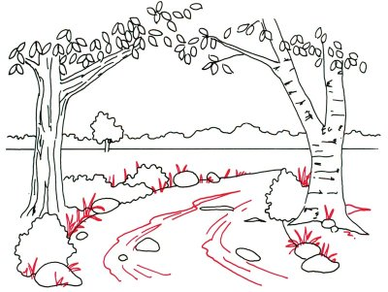

Step 4: Make a series of roughly parallel lines to look like ruts on the surface of the roadway. Sketch several clumps of tall grass at the edge of the road and around the bushes. Shape them like spikes: mostly upright, but a few are bent over.

To finish your rural lane drawing, lightly shade the rocks

Step 5: Heavily shade the area between the horizon and the top of the tree line. Add short, squiggly lines to the distant tree. Use the same method for the bushes along the roadway. Sketch a few very short lines to look like tufts of grass in the field. As the last step, lightly shade the rocks.

Your landscape drawing is finished! Even if you don't get it right the first time, keep practicing until you're happy with your drawing.

